Lab 2: Create HTML Files
Name: Yem Phalpichkiri
Class: M2
Color.html
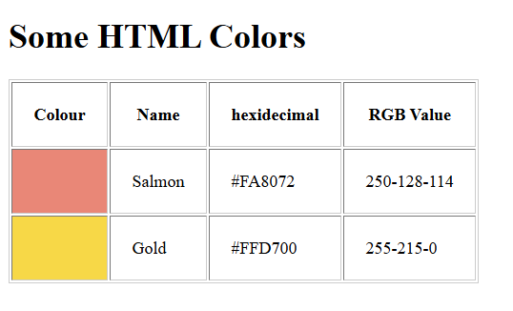
book.html
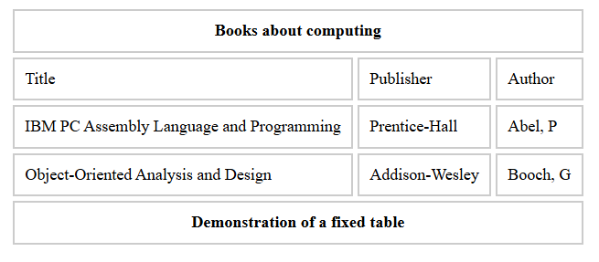
timetable.html
